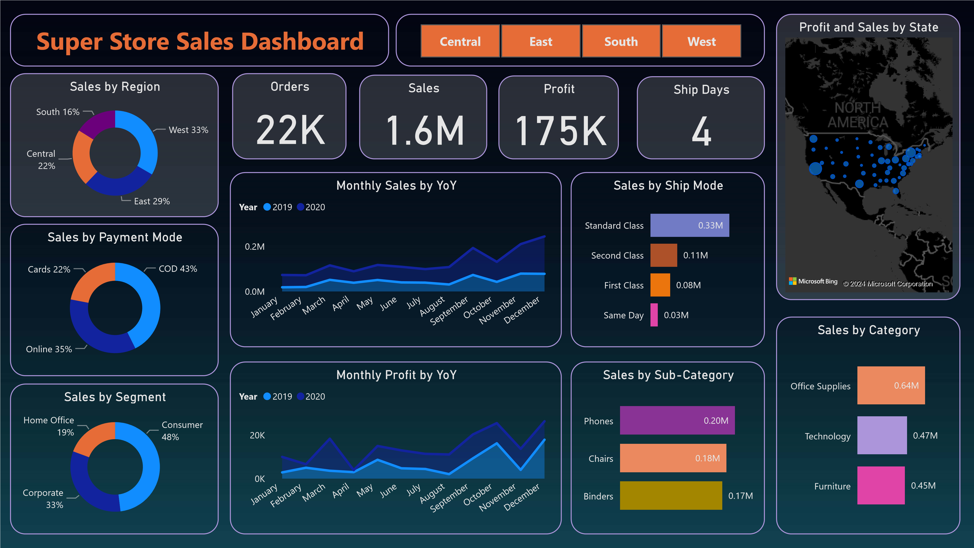

Power BI Desktop



Sales Forecast - 15 days

Order Date

Jan 2019

Apr 2019

Jul 2019

Oct 2019

Jan 2020

Apr 2020

Jul 2020

Oct 2020

Jan 2021

Sales Forecast - 15 days

Order Date

Nov 2020

Dec 2020

Jan 2021

Sales by State

State

**California**

**New York**

**Texas**

**Washington**

**Pennsylvania**

**Ohio**

**Illinois**

**Florida**

**Michigan**

**North Carolina**

**SuperStore Sales Forecast - 15 Days Forecast**